# Reddit Analytics Bot UML Diagrams

## Use-Case Diagram

Reddit users can interact with the bot by submitting a comment in a post using specific keywords such as “ci_rae activity”. The bot processes the request and posts a reply back to the user in the reddit post. The admin can also call the database via a UI client and the request returns the processed query. The below diagram contains only a few examples of the functionality of the bot. More functions can be added later.

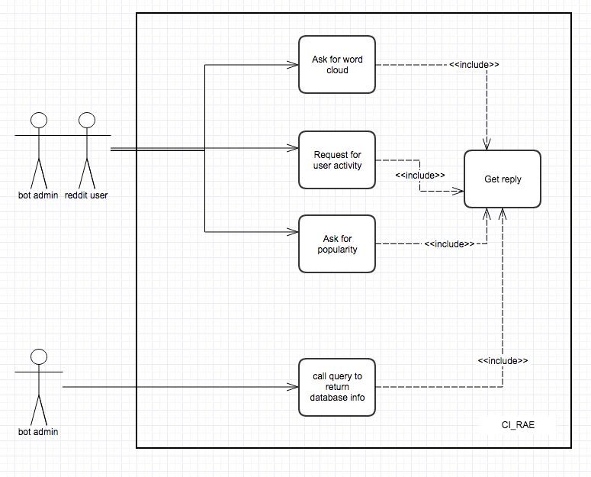

## 

## Class Diagram

The system will be composed of two primary modules: the Bot module and Analytics Engine module. Each module will be made of several classes, for separate specific purposes.  
  
The main class in the Bot module will be the one that authenticates the bot’s access to Reddit using the Python Reddit API Wrapper along with OAuth2 tokens granted by Reddit. Following authentication, the bot will run in a continuous loop as it scans reddit for user data analytics requests. Other notable classes in the bot module include the ServerResponseParser which will take user data given by Reddit, parse it, and store it; and the OutputQueue which will responsible for delivering the output of the user’s request back to the user through Reddit.

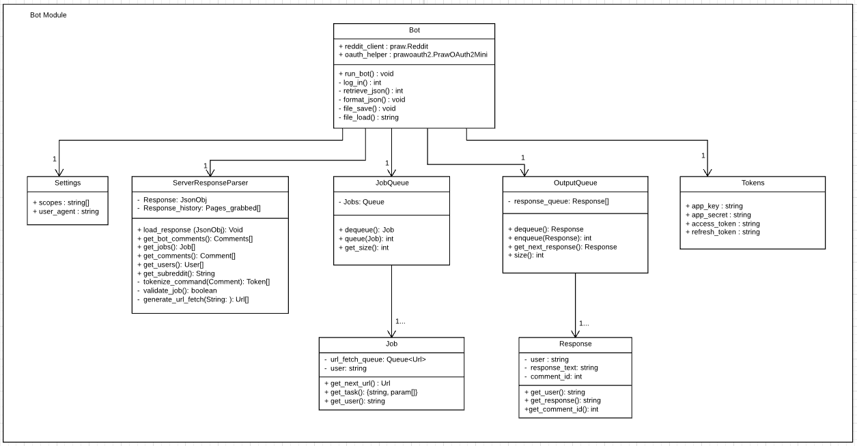

The Analytics Engine module will take the data parsed by the Bot module and run analyses on it. Each class in the Analytics Engine module will handle a different set of analytics. For example, the Subreddit class will gather data about the user’s subreddit interests and popularity.

*(Continued on next page)*

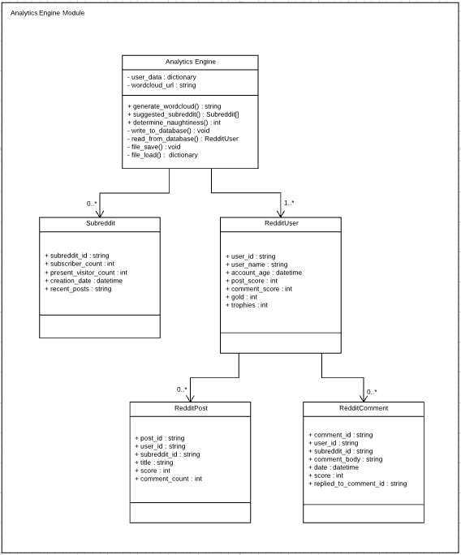

## Sequence Diagram

When the reddit bot receives an activity command, it calls for the analytics engine to generate a report on when the users is most active. The analytics engine then asks the database for the users data, and after receiving it proceeds to generate the report. A link to the report is then passed back to the reddit bot, which posts as a reply to the users command on reddit. A similar sequence occurs with the other commands, such as popularity and world cloud.

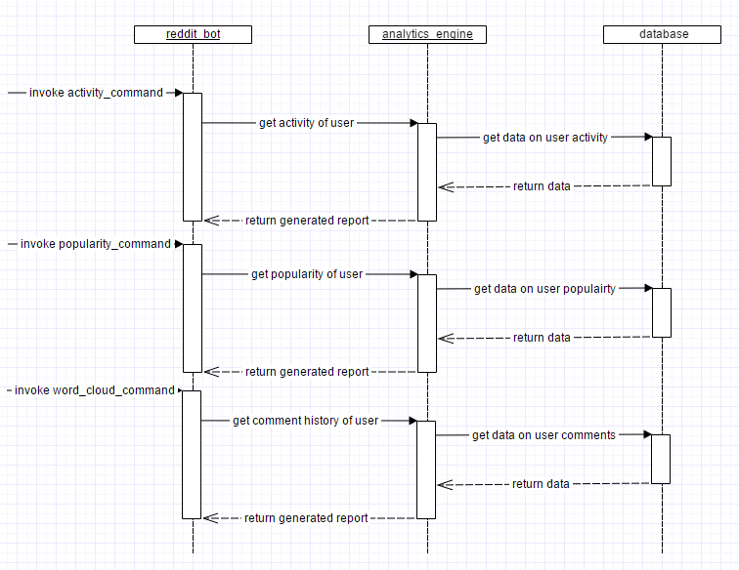

## 

## Statechart Diagram

Assuming moderate amounts of request traffic, the engine will spend 99% of its time waiting for user input in the Reddit Request state. Once a request has been found and validated, the program will enter a request processing state where it must perform each of the data analytics requests the user has specified. If a request is found to be invalid, an error message is immediately returned to the user.  
  
The processing state will need direct access to the user data database, which will contain all of the user data given by the Reddit servers as well as some analytics data generated by the Reddit Analytics Engine software. If an error occurs during the analytics, the analytics halts and the program skips ahead to the Response State.  
  
Once all user data analytics requests have been processed, the program enters the Response Generation State, triggering string building and image/graph generation events as needed. Finally, this generated output is sent to the Response State where it is returned to the user via Reddit.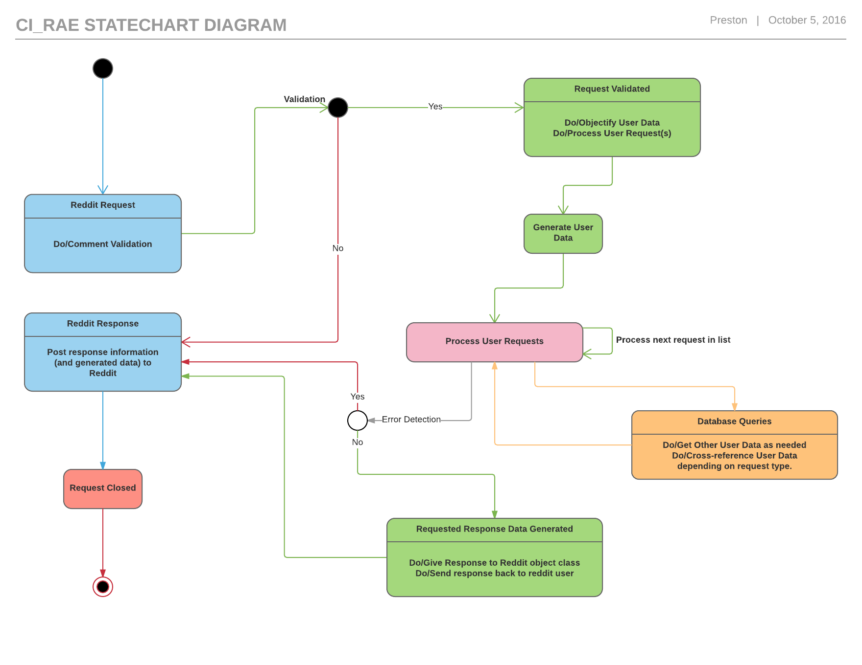

## Activity Diagram= (WIP)

There are three main activity partitions: Reddit Bot, Analytics Engine, and Database. Transitions show which activity states follow after another. The first activity state is when the Reddit bot will be called by a Reddit user with a command as a parameter. The bot will then grab the needed data through the Reddit API. The data and the user command will then be sent to the Analytics Engine.

The AE will receive the command and data from the bot. A guard decision (whether or not the user command is “help” or not) will determine the next set of transitions. If the enter command is help, the data to be sent back to the bot will be help information. If the user entered a non-help command, a query will be sent to the database.

The database will receive the request from the AE. A guard decision (whether or not the user exists in the database or not) will determine the next set of transitions. If the user who issued the command is found in the database, the user’s data will be updated. If the user is not found, the new data will be added to the database. The requested data is then sent back to the AE. Depending on the the type of command, a form of analytics will be performed on the data. An image of a graph, word cloud, chart, etc. will be uploaded to Imgur, an image host, through the Imgur API. The analytics data will then be sent to the bot.

The bot receives the data from the AE and the final state is when the bot posts the analytics on Reddit as a comment on the initial call by the user.

*(Continued on next page)*

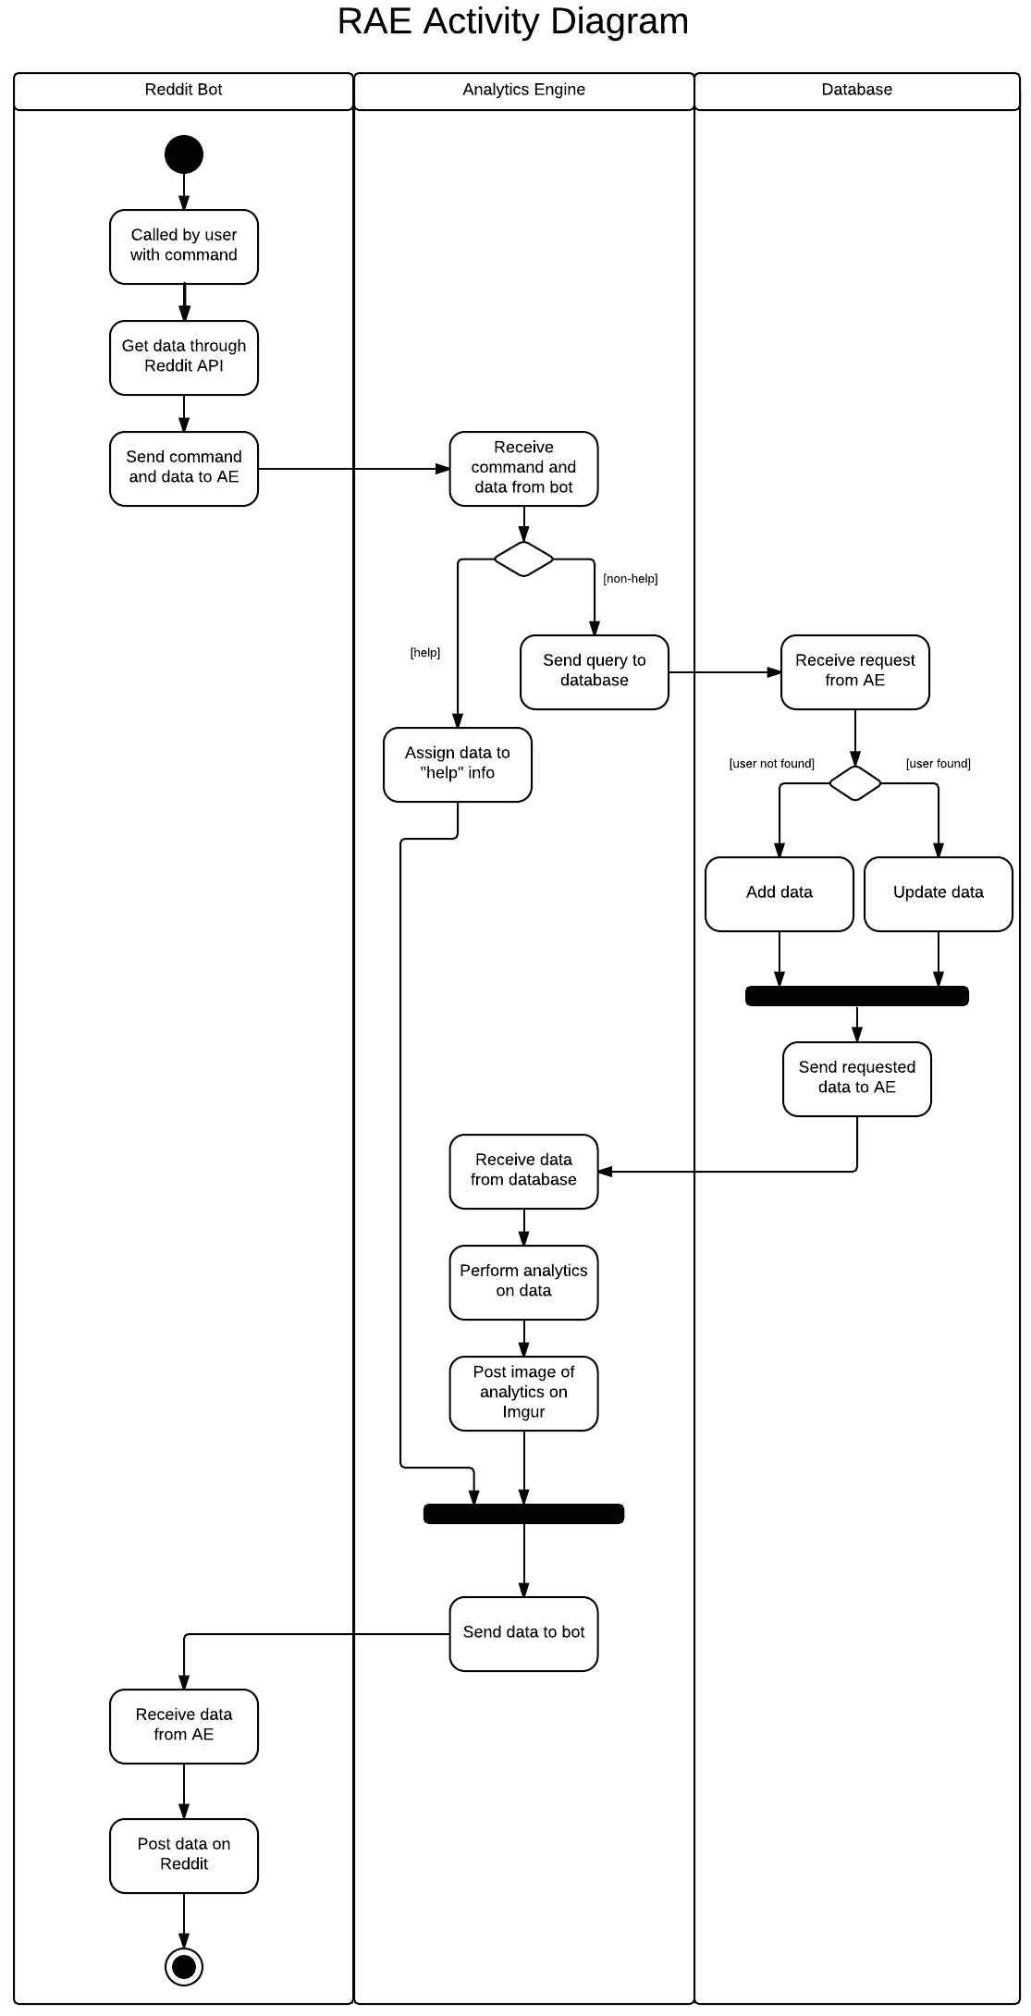

## Component Diagram

The R.A.E bot component will fetch any required data from reddit while also monitoring comments on it’s corresponding reddit account’s post. The Response Parser takes responses and contextualizes them, dividing collected user data from comments on the bot. Comments on the bot are used to produce job objects that are stored in the Traffic Queue component. Data not related to jobs is sent to the database for use in queries and analysis. Jobs from the traffic component flow to the analysis engine for execution. Responses to jobs flow to the Traffic Queue from Analysis Engine. The Analysis Engine produces responses by extracting information specified by jobs from the database. Any additional information needed for analysis can be requested by the Engine if the Database cannot answer the query. Once a response is finalized, the R.A.E Bot produces responses as per schedule policy.

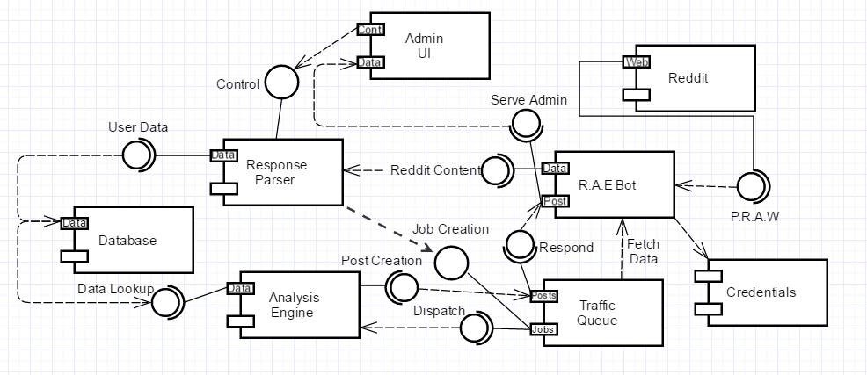

Deployment Diagram

* The deployment will consist of three devices. The Reddit Server, Analytics Server and Reddit Bot Server.
* The Reddit Server is owned by Reddit Inc. and provides an API so that our bot may access public information about users as well as notifications. We will be using the Python Reddit API Wrapper (PRAW) framework to enable easy access to this API.
* The Imgur Server is owned by Imgur LLC and provides an API so that our bot may upload analytics photos to their database. We will be using the Pyimgur framework to simplify the process of uploading photos.
* The Analytics Server will contain a MySQL database of all analyzed users. Information will be accessed and appended by the Reddit Bot Server.
* The Reddit Bot Server will contain server modules that will access data using PRAW, package the data into a python friendly format and perform analytics. It will use the MySQLLdb framework to easily access/append user information in the MySQL database located in the Analytics Server. After performing analytics, it will send the analysed data back to the Reddit Server using PRAW.

